**Topic:** Is Adderall a Narcotic in 2023 – Vigoursoul

**Focus keyword:** Is Adderall a Narcotic

**Meta Title:** Is Adderall a Narcotic in 2023 – Vigoursoul

**Meta Description:** Is Adderall a narcotic? Flawless contributes to Adderall misuse. Our California addiction treatment clinic is aware of the hazards of Adderall**.**

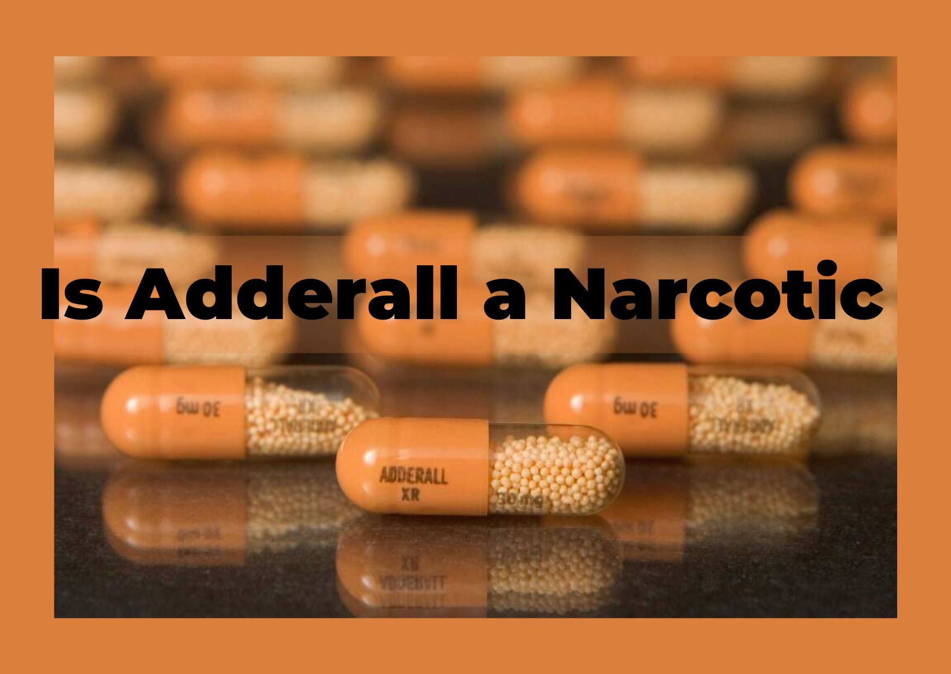

Is Adderall a Narcotic? Not exactly. A narcotic is a type of pain medicine prescribed by a doctor. Adderall is classified as an amphetamine, yet it has the same high risk for addiction as conventional drugs.

**Table of content:**

**What is Adderall?**

Adderall is a brand name for a medication that contains both amphetamine and dextroamphetamine. Both medicines are stimulant medications that work on the central nervous system. The medicine works by increasing the amount of substances in the brain that act on receptors, including dopamine and norepinephrine.

**Is Adderall Narcotic Yes or No?**

Given the present emphasis in the United States on minimizing opioid usage, many people ask if Adderall is an opioid. No, it does not.

**Is Adderall a Class 2 Narcotic?**

Morphine, opium, codeine, and hydrocodone are also Schedule II drugs. Amphetamine (Dexedrine®, Adderall®), methamphetamine (Dioxin®), and methylphenidate (Ritalin®) are examples of Schedule IIN stimulants. Am barbital, glutethimide, and pentobarbital are among the other Schedule II drugs.

**Is there a Non-narcotic Alternative Adderall?**

Atomoxetine (Strattera) is an FDA-approved no stimulant for the treatment of ADHD. It belongs to a family of drugs called as selective norepinephrine reuptake inhibitors.

**Is Adderall a Narcotic Drug?**

A medication used to alleviate moderate to severe pain. Narcotics are similar to opiates such as morphine and codeine, but they are not derived from opium. They attach to opioid receptors in the brain and spinal cord. Opioids are the new name for narcotics.

**Is Adderall an Opioid?**

Given the present emphasis in the United States on minimizing opioid usage, many people ask if Adderall is an opioid. No, it does not. Opioids are drugs derived from opium, thus the name. These drugs often have a central nervous system depressive impact. Adderall, on the other hand, is a stimulant medicine that has the opposite impact of opioids. When used in significant dosages, these substances can generate a euphoric "high" and lead to addiction. According to a 2011 research, the variations in how these substances influence the dopamine receptors in the brain result in different addiction processes and addictive behaviors.

**SNORTING ADDERALL IS DANGEROUS:**

When recommended by a doctor, Adderall is given in pill form with a set dosage. When someone buys Adderall illegally, they will use it in a different way. Adderall pills obtained illegally are frequently crushed and snorted.

However, snorting Adderall has a number of negative side effects. One of the most significant effects happens in the nasal cavity of a person. In addition to producing dry skin and nosebleeds, chronic use of the septum will cause it to deteriorate. A teen who snorts Adderall without a septum will have a hole within their nose, increasing the risk of infection.

When a youngster buys Adderall illegally, they have no way of knowing if the amount is appropriate for their body. Furthermore, smashing pills alters the time-release of Adderall, presenting the user with a bigger dose and reaction all at once. As a result, snorting Adderall raises the danger of an overdose, which can be fatal.

**ADDERALL SYMPTOMS:**



Snorting Adderall on a regular basis is a clear symptom of addiction. When this occurs, teens will use Adderall in higher dosages and for a longer amount of time than intended. In both cases, the adolescent user develops tolerance and dependence on Adderall. When someone quits taking Adderall without a prescription, they will suffer the following withdrawal symptoms:

* Tiredness
* Insomnia
* Difficulty waking up
* Bigger appetite
* Uncontrolled or slow movements
* Frightful dreams
* Anxiety or depression

**Side Effects of Adderall:**

Adderall's favorable side effects include improved alertness and wakefulness, enhanced attention, and a calm disposition. Other possible adverse effects include:

* Nervousness
* Restlessness
* Headaches
* Dizziness
* Insomnia
* Mouth dryness
* Hoarseness
* Vision changes
* Speech slowed

**Long-Term Effects of Adderall Use:**

Adderall, like other stimulant drugs, inhibits appetite. This can result in lower nutrient intake and delayed growth in children who are on a long-term medication. Long-term use can also lead to medication tolerance. If Adderall is suddenly stopped, tolerance can lead to dependence and withdrawal.

**Treatment for Adderall Addiction:**

1. **Detox**

Therapy for Adderall addiction, like treatment for other addictive drugs, needs a period of detoxification, or "detox," in which the medication is eliminated from the body. Detox from the substance should be treated properly by a doctor, as withdrawal symptoms can be unpleasant and extreme symptoms might be deadly. If withdrawal symptoms are minimal, a person can detox at home under the guidance of a doctor. If the symptoms are severe or life-threatening, detox may need to be performed in a medical facility.

**2-Ongoing Recovery**

Once detox is done, Adderall addiction recovery may begin. Depending on the length and intensity of the addiction, this might take happen in either an inpatient or outpatient environment. There are presently no drugs authorized to treat Adderall addiction.

People suffering from Adderall addiction may benefit from The Matrix Model of therapy.

10 This strategy entails extensive outpatient therapy utilizing a number of therapeutic modalities such as:

* Individual guidance
* Groups for relapse prevention
* Educational organizations
* Groups for social assistance
* Urine and breath analysis

The Matrix Model curriculum is generally 16 weeks long. Non-confrontational treatment focuses on recognizing and modifying addictive behaviors. This type of treatment is particularly beneficial for persons suffering from stimulant drug addiction.

**FAQS**

**How is Adderall Used?**

Adderall can assist persons with attention deficit hyperactivity disorder (ADHD) improve their attention, focus, and concentration while lowering impulsive behavior and hyperactivity. According to a 2013 research, stimulant drugs aid to improve episodic memory, reduce strong emotional reactions to frustration, boost effort, and improve the capacity to spot faults at work.

**How Long Does Adderall Last?**

The effects typically last 4 to 6 hours. The exact duration of impact is determined by factors like as weight, metabolism, and medicine dose. Adderall XR is designed to be released more slowly in the body, allowing it to last up to 12 hours.

**What Works Just as Good as Adderall?**

If Adderall isn't suited for you, your doctor may suggest other prescription drugs for ADHD, such as: dexmethylphenidate (Focalin XR) (Focalin XR) methylphenidate lisdexamfetamine (Vyvanse) (Concerti, Ritalin).

**Is Adderall Mentally or Physically Addictive?**

Stimulant medicines, such as Adderall, are addictive, and taking them recreationally increases the likelihood of establishing a psychological and physical reliance on them. Side effects of Adderall include: physical harm to the brain, internal organs, and systems.

**How does Adderall affect you socially?**

Misuse of Adderall might cause a person to withdraw from friends and family and become socially isolated. At the same time, when the individual does communicate with others, it is possible that Adderall or other drug usage is what they share in common.

**Conclusion:**

Although Adderall is often used to treat ADHD, it is a medicine that should not be abused or misused. Long-term abuse can result in life-threatening symptoms and addiction. If you or someone you love is suffering from Adderall abuse or addiction, there is assistance available and recovery is achievable.